1. **Configure VPC peering in cross regions.**

* **First we need to create to separate vpc,subnet,route,INT-GW …we are creating two separate vpc from different region and also some region as vpc instances but make changes in networking select ur region wise vpc and subnet**
* **Make sure you enable host name from vpc > action > edit vpc setting > dns setting > enable dns hostname.**

**Request side peering  
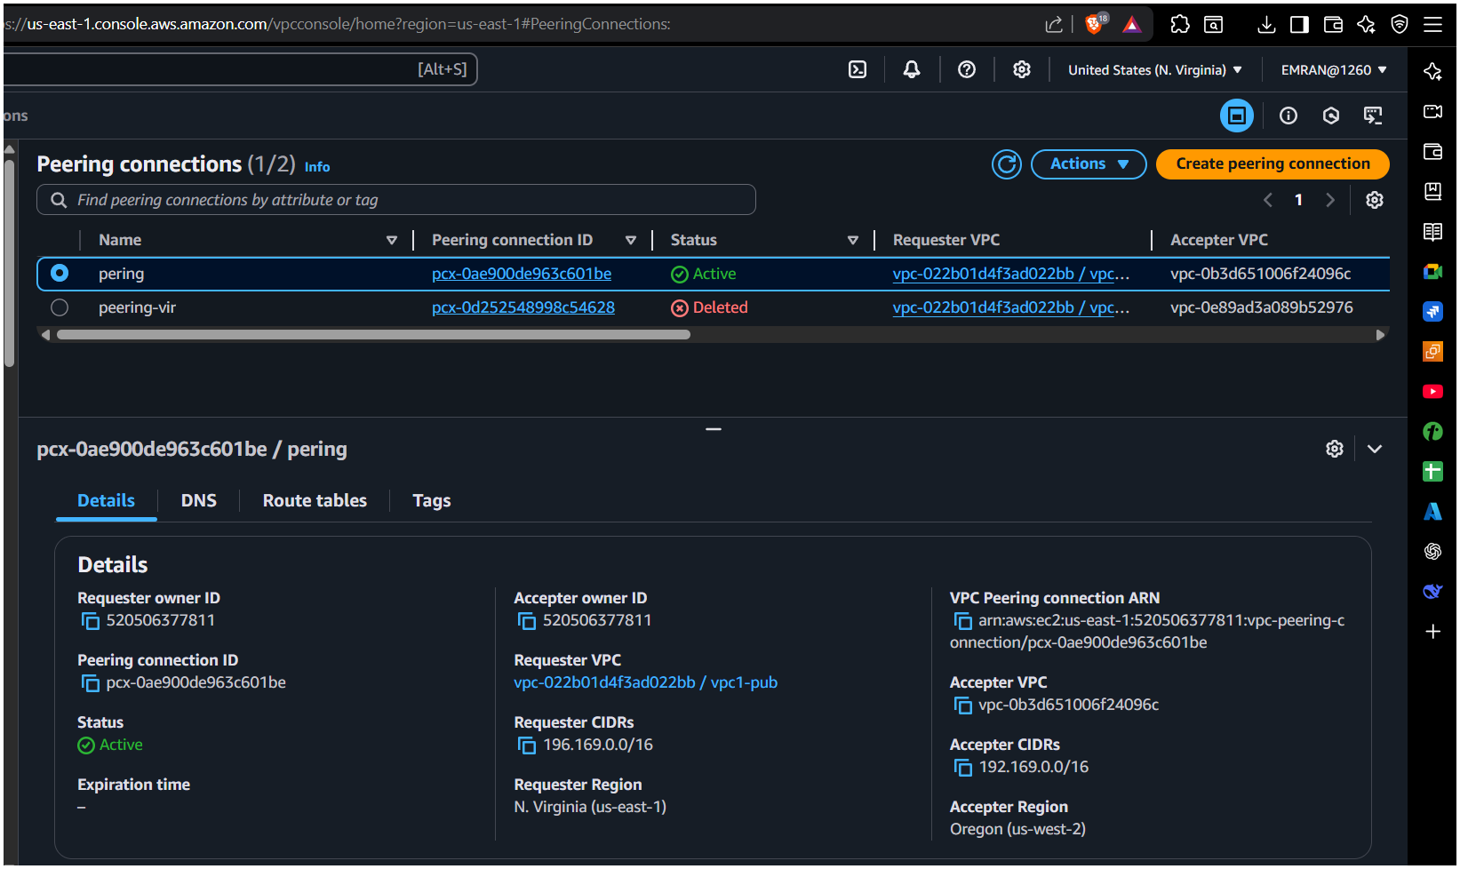**

**Accepter side peering**

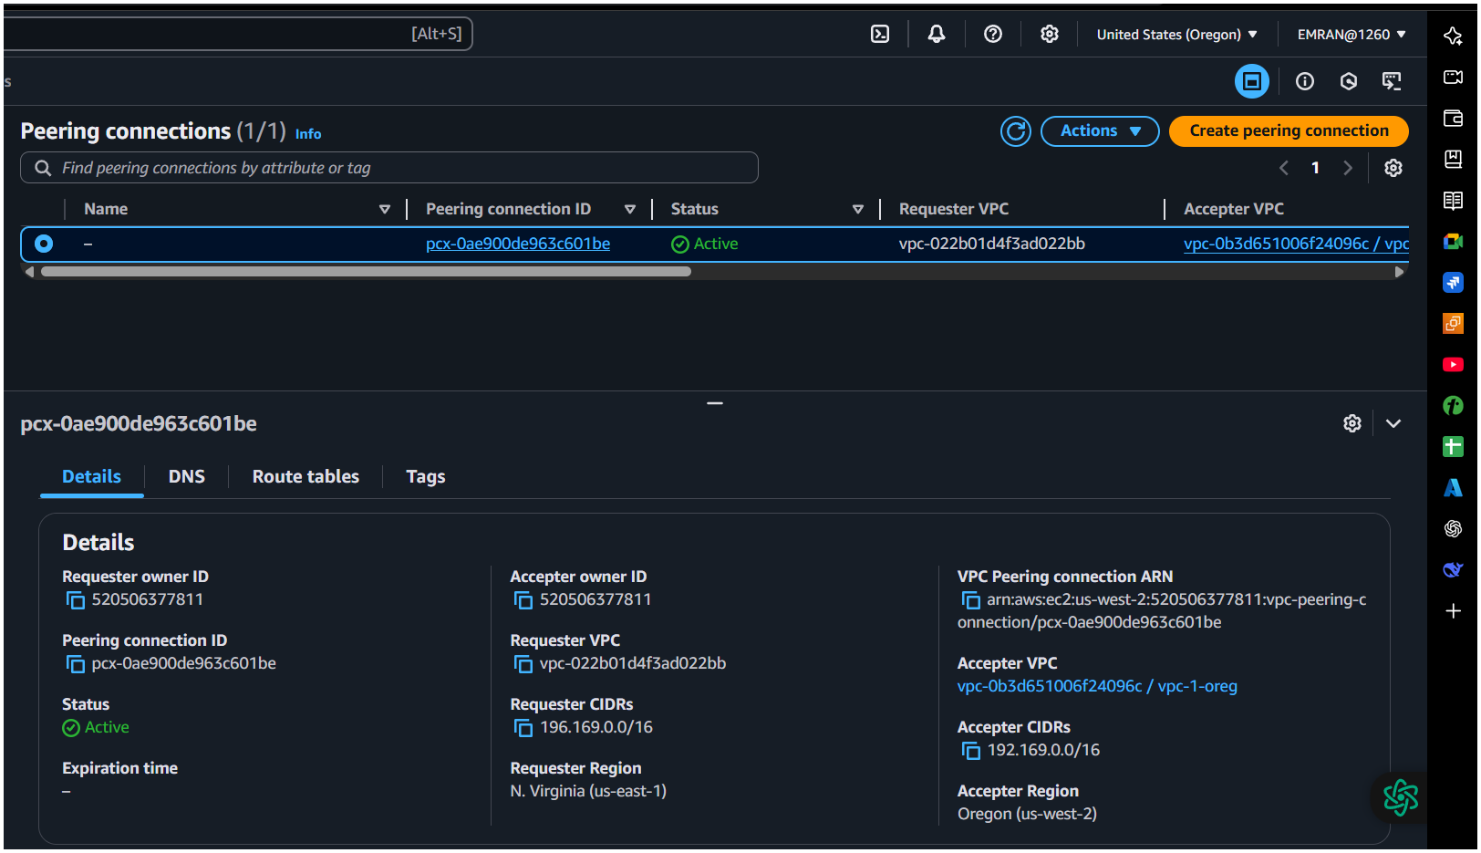

**Checking connection**

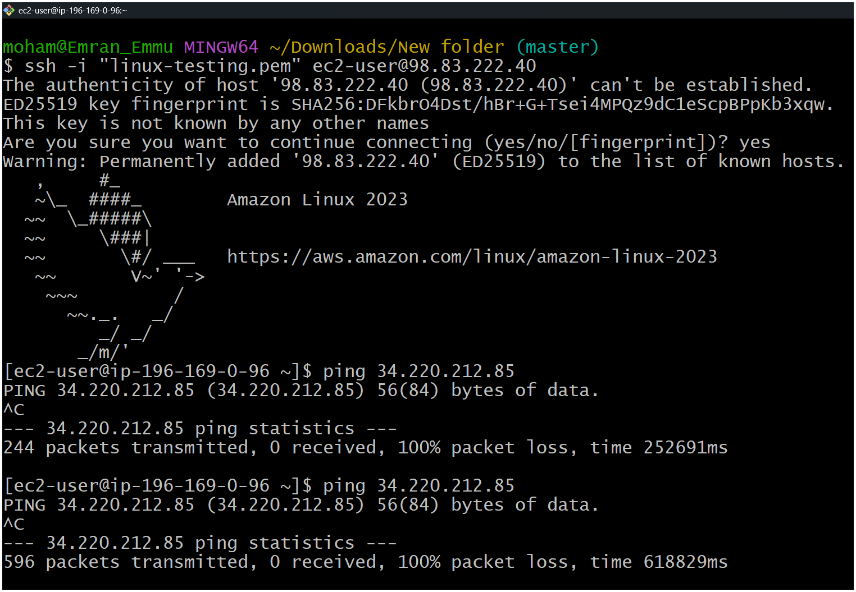

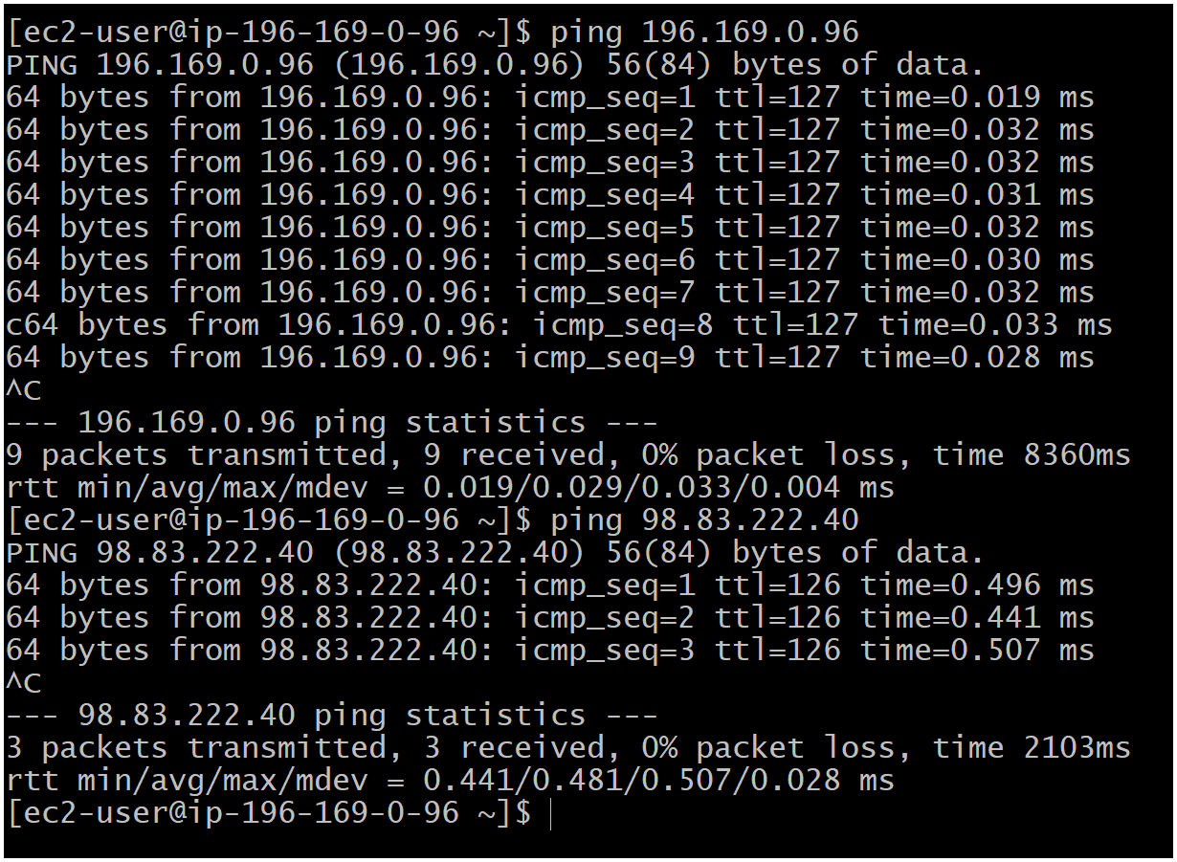

1. **Purchase one domain from godaddy.**

**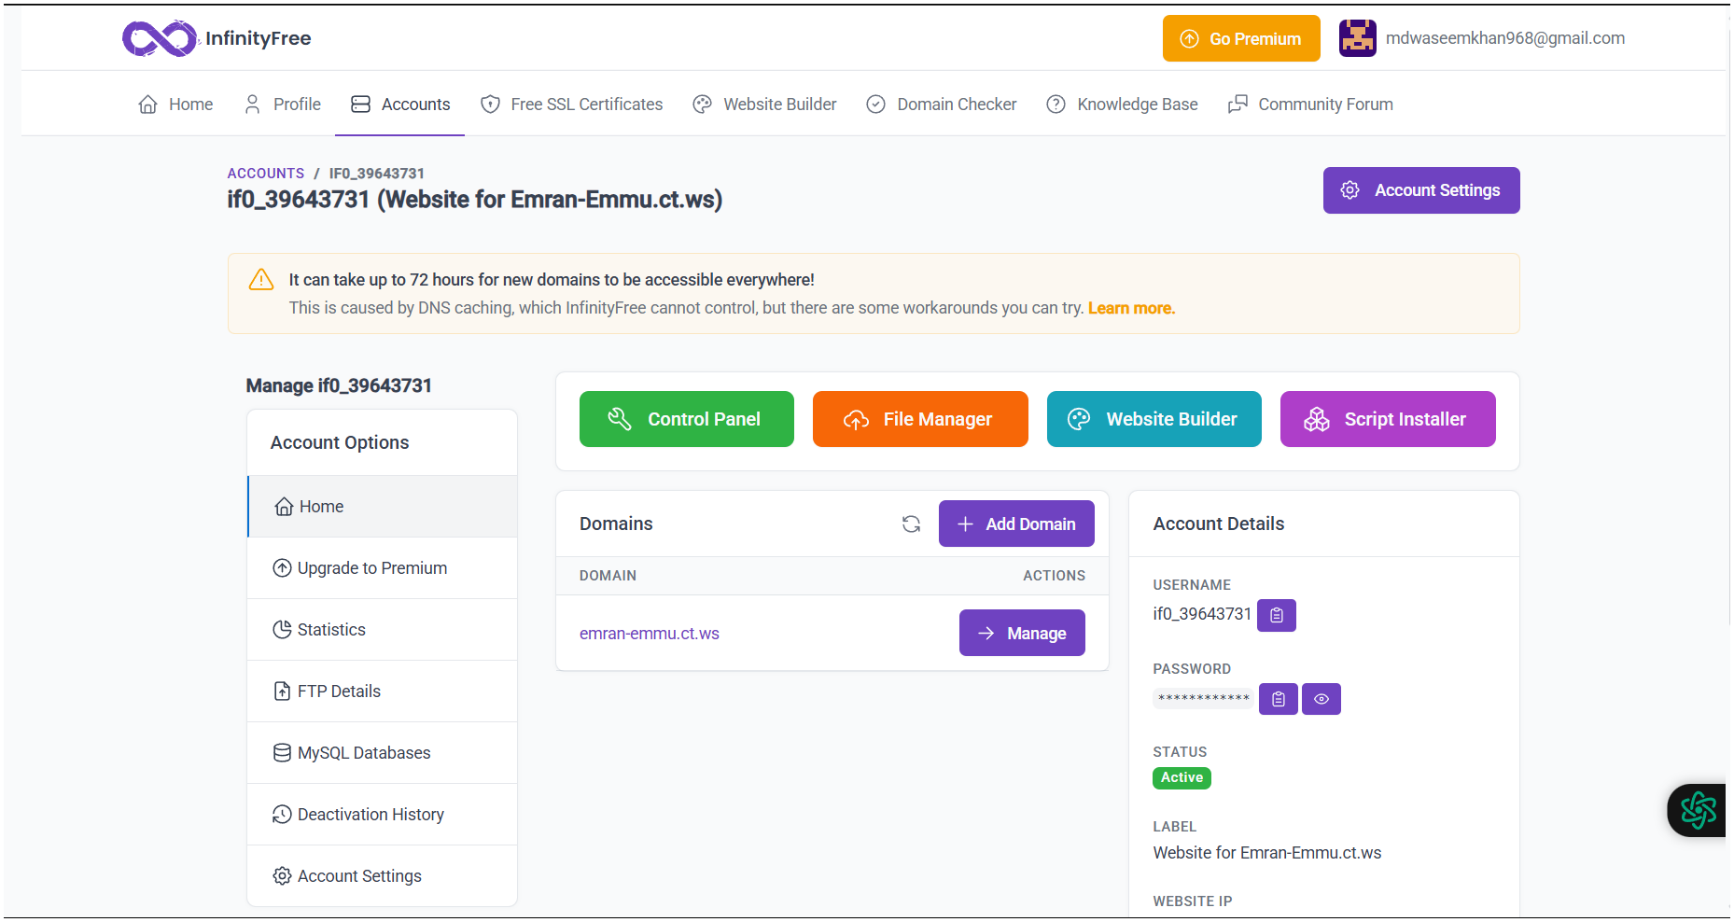  
 Emran-Emmu.ct.ws**

1. **Deploy static webiste in s3.**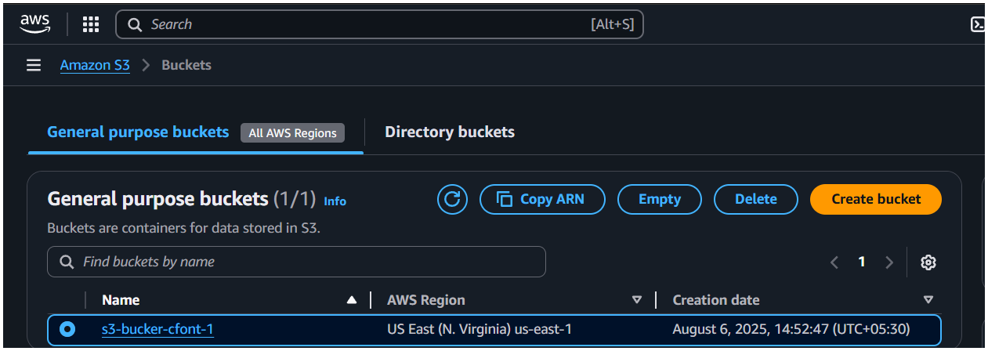

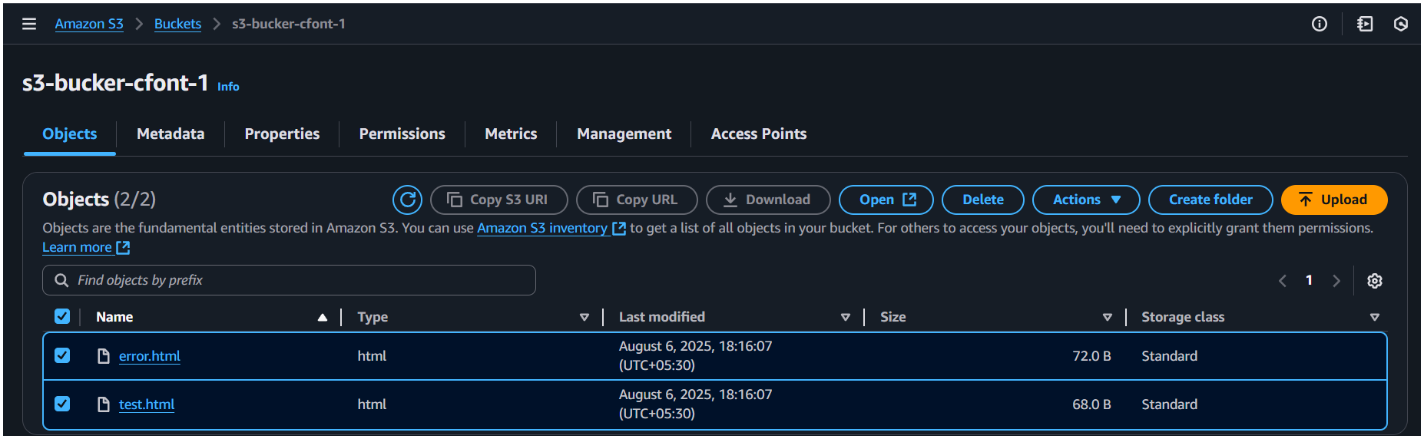

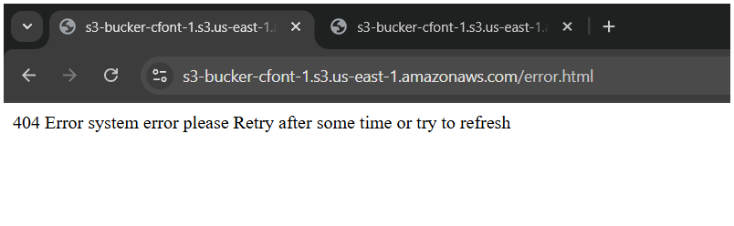

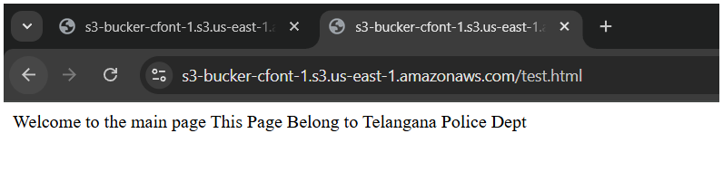

**4) Create CDN and attach one SSL certificate.**

**5) Create Route53 hosted zone and MAP the domain with CDN.**

**6) Update the index.html in s3 bucket and the updated file should be accessible by using domain name.**

**7) Share the Domain name in slack to test the connetivity.**